CO-3 AT-2
DESIGN TASK

NAME: G R AAKAASH REG NO: 192412068
SLOT: A COURSE FACULTY: K. SATHISH

QUESTION-1 : Design a system architecture for Multi-access Edge Computing to reduce latency in smart traffic applications.
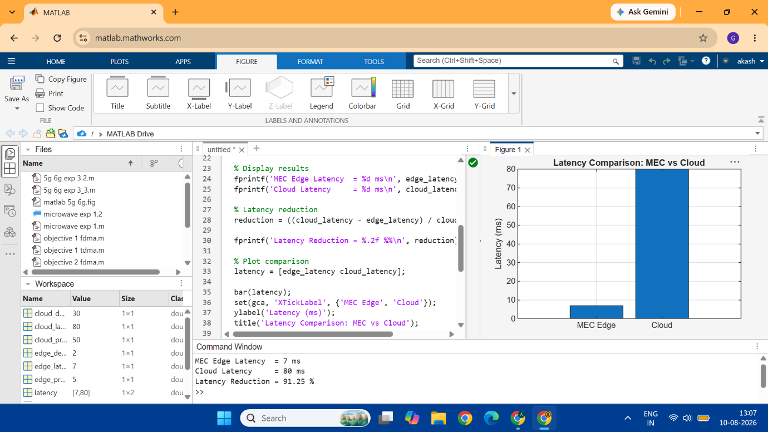
CODE: clc;
clear;
close all;

% Number of vehicles
N = 50;

% Generate traffic data from vehicles
traffic_data = randi([10 100], 1, N);

% Processing time
edge_processing_time = 5; % ms
cloud_processing_time = 50; % ms

% Communication delay
edge_delay = 2; % ms
cloud_delay = 30; % ms

% Total latency
edge_latency = edge_processing_time + edge_delay;
cloud_latency = cloud_processing_time + cloud_delay;

% Display results
fprintf('MEC Edge Latency = %d ms\n', edge_latency);
fprintf('Cloud Latency = %d ms\n', cloud_latency);

% Latency reduction
reduction = ((cloud_latency - edge_latency) / cloud_latency) * 100;

fprintf('Latency Reduction = %.2f %%\n', reduction);

% Plot comparison
latency = [edge_latency cloud_latency];

bar(latency);
set(gca, 'XTickLabel', {'MEC Edge', 'Cloud'});
ylabel('Latency (ms)');
title('Latency Comparison: MEC vs Cloud');
grid on;

QUESTION-2: Develop a cloud-edge communication model for wireless healthcare monitoring.
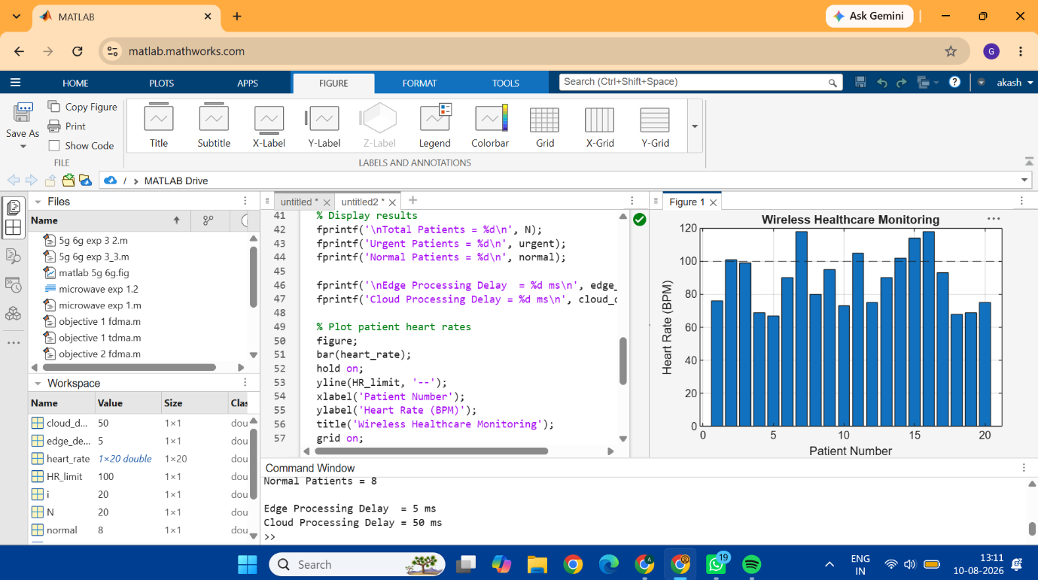
CODE: clc;
clear;
close all;

% Number of patients
N = 20;

% Generate patient sensor data
heart_rate = randi([60 120], 1, N);
temperature = 36 + rand(1, N) * 2;

% Threshold values
HR_limit = 100;
Temp_limit = 37.5;

% Edge and cloud delay
edge_delay = 5; % ms
cloud_delay = 50; % ms

urgent = 0;
normal = 0;

% Process healthcare data at edge
for i = 1:N

if heart_rate(i) > HR_limit || temperature(i) > Temp_limit

urgent = urgent + 1;

fprintf('Patient %d: URGENT - Edge Alert\n', i);

else

normal = normal + 1;

fprintf('Patient %d: Normal - Send to Cloud\n', i);

end
end

% Display results
fprintf('\nTotal Patients = %d\n', N);
fprintf('Urgent Patients = %d\n', urgent);
fprintf('Normal Patients = %d\n', normal);

fprintf('\nEdge Processing Delay = %d ms\n', edge_delay);
fprintf('Cloud Processing Delay = %d ms\n', cloud_delay);

% Plot patient heart rates
figure;
bar(heart_rate);
hold on;
yline(HR_limit, '--');
xlabel('Patient Number');
ylabel('Heart Rate (BPM)');
title('Wireless Healthcare Monitoring');
grid on;

